Attach Front End (Web Application) and Back End (Database) Application

**Step 1: Launching an AWS instance for running WordPress Application**

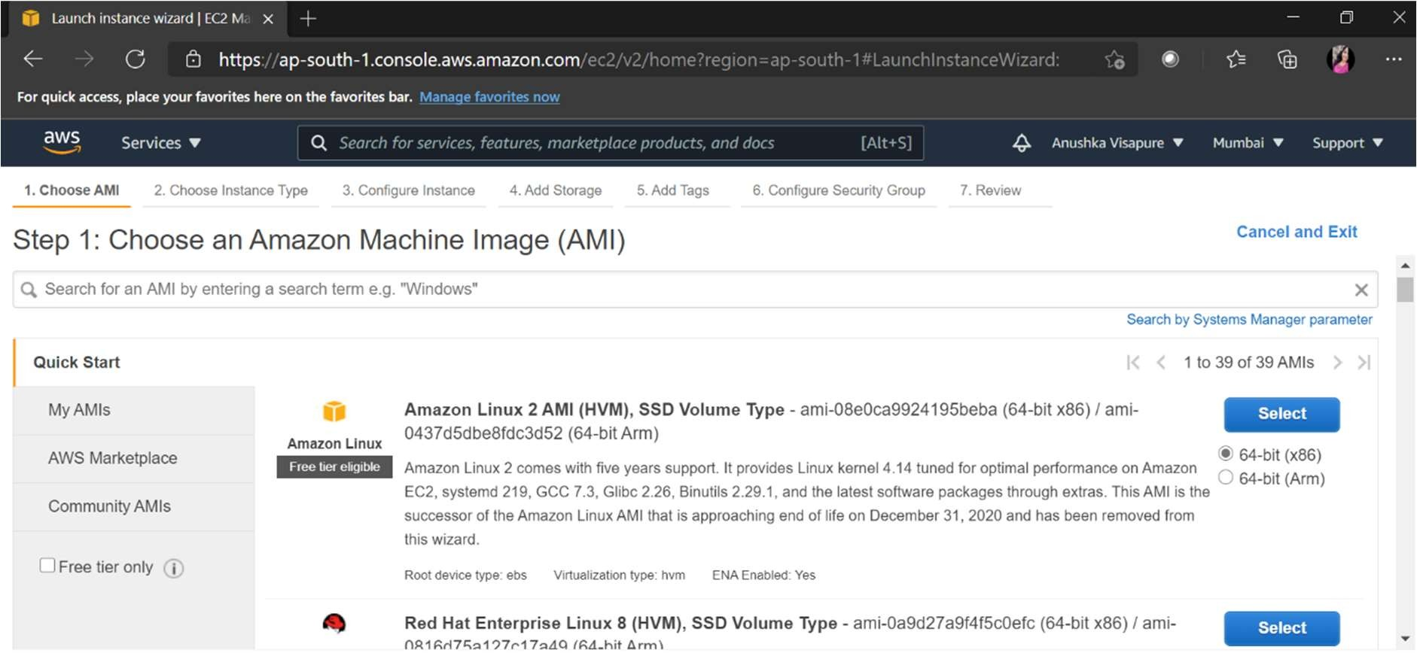

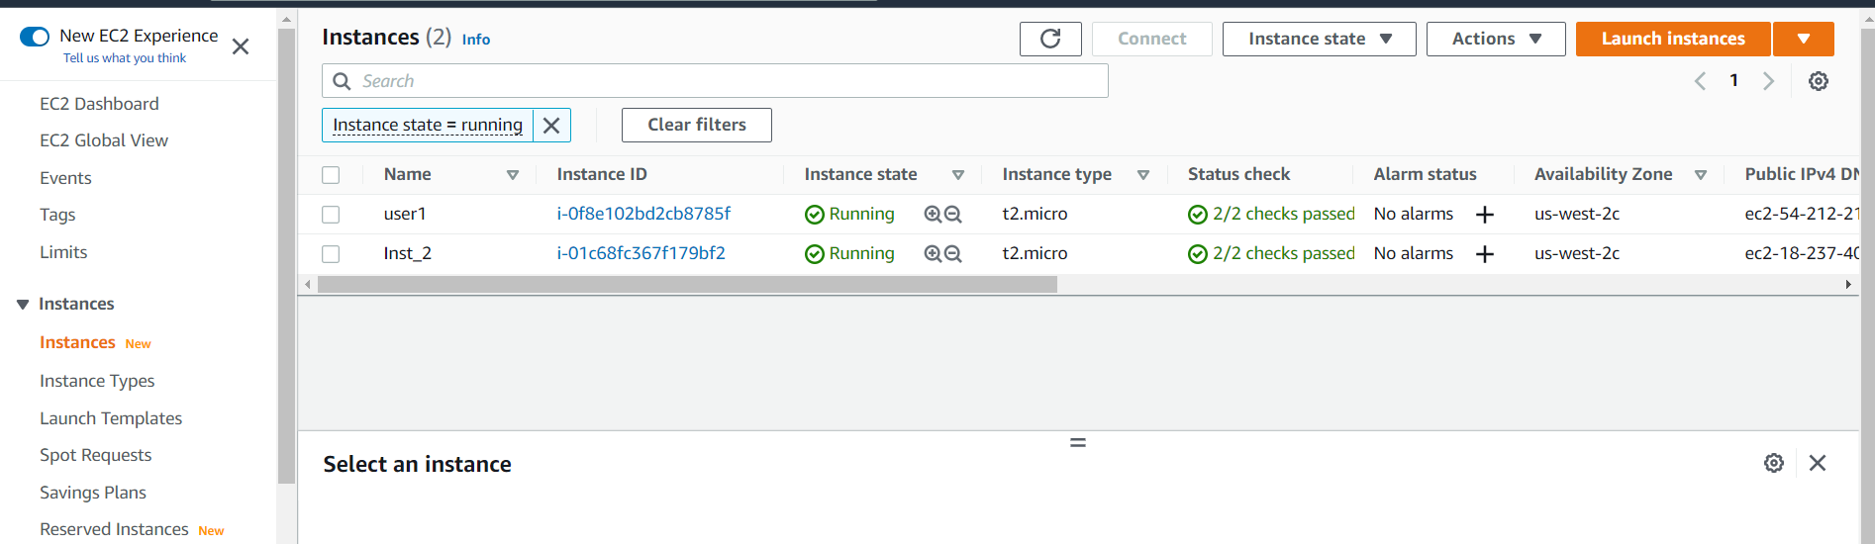

**Step 2 : Installing Httpd software in Instance**

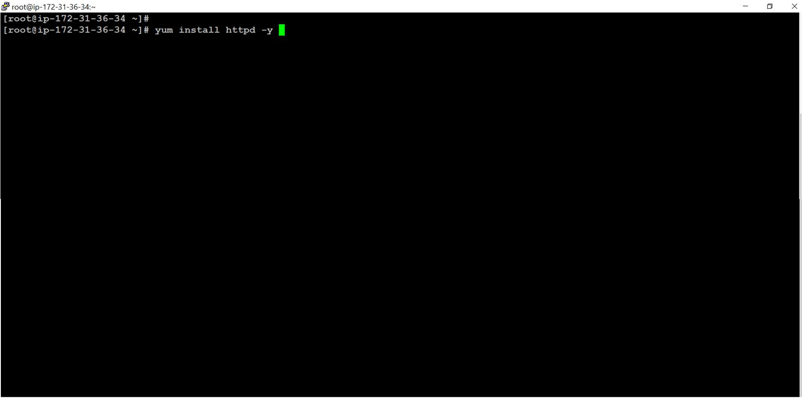

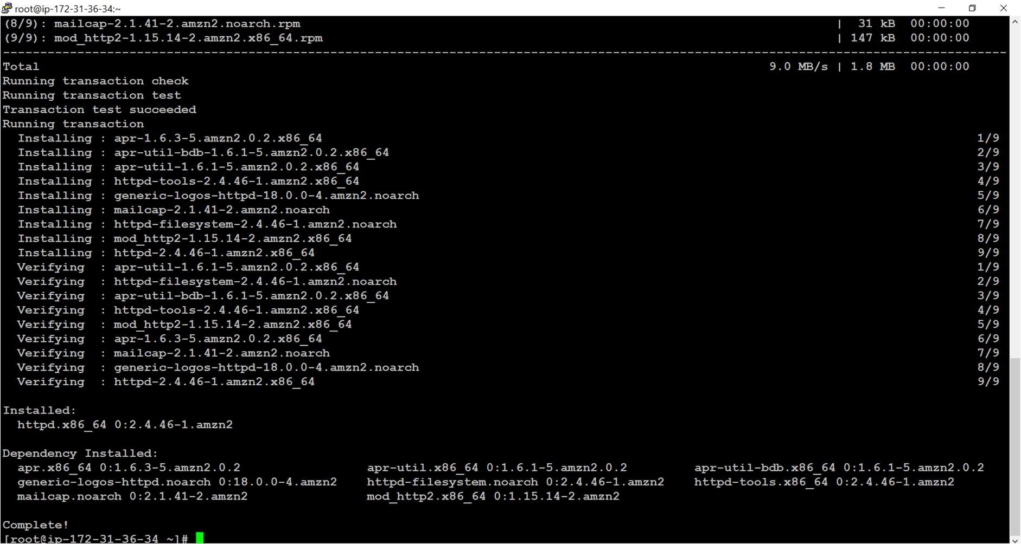

**Step 3 : Start the httpd server and make it permanent**

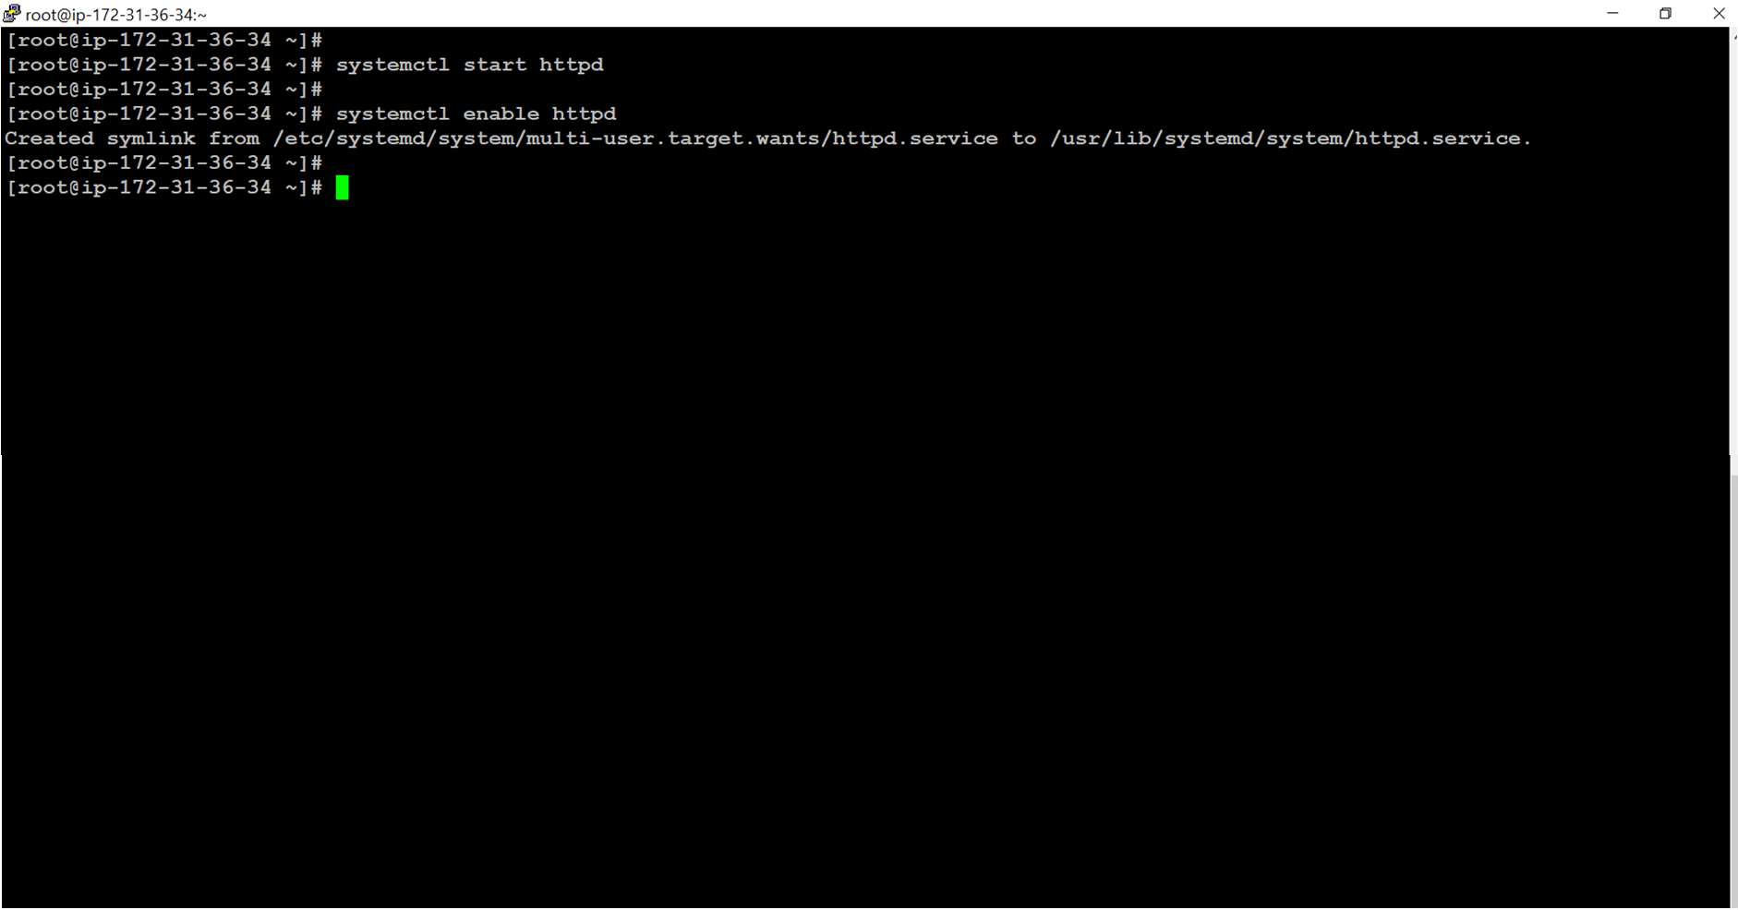

**Step 4 : Check the httpd server has been started or not**

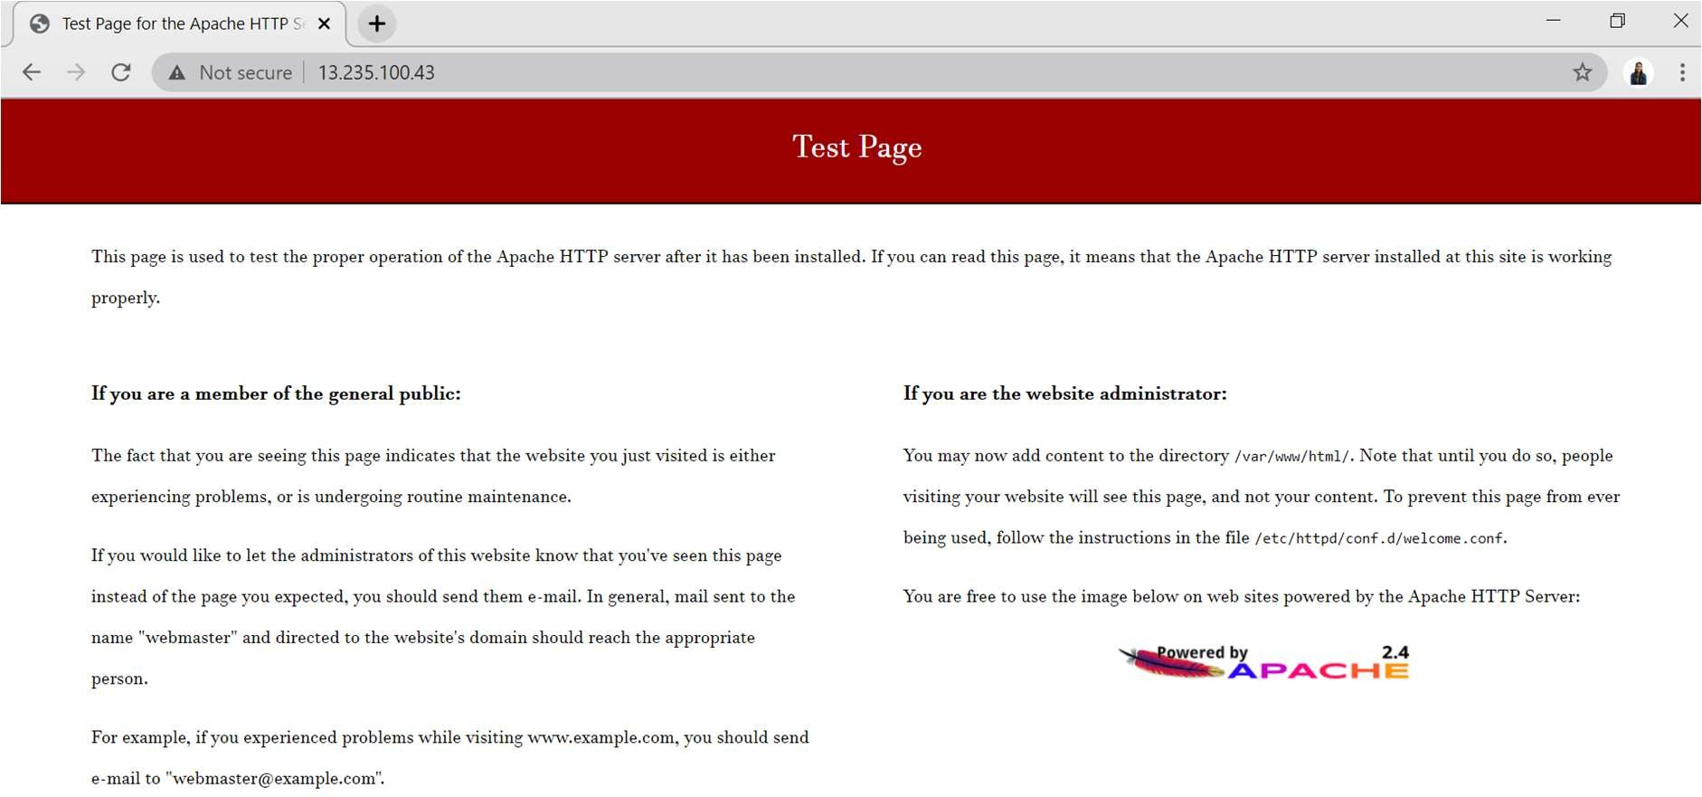

**Step 5 : Installing Database in Instance**

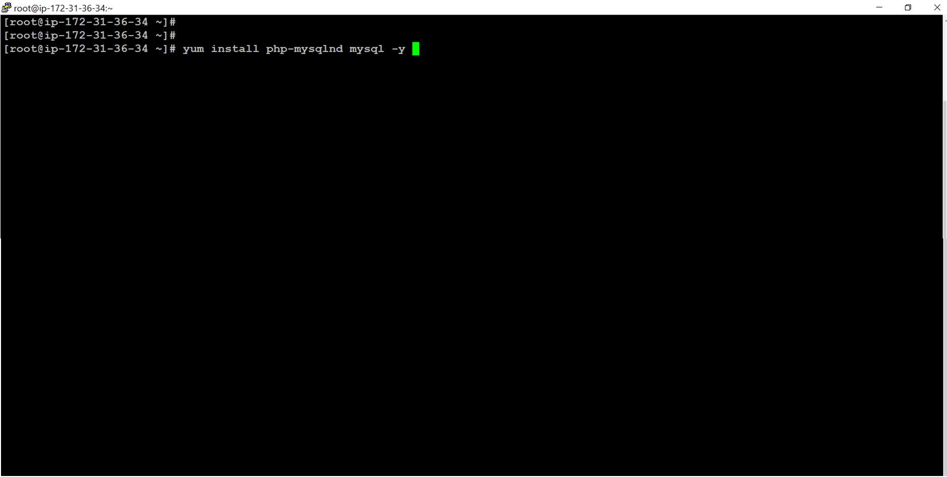

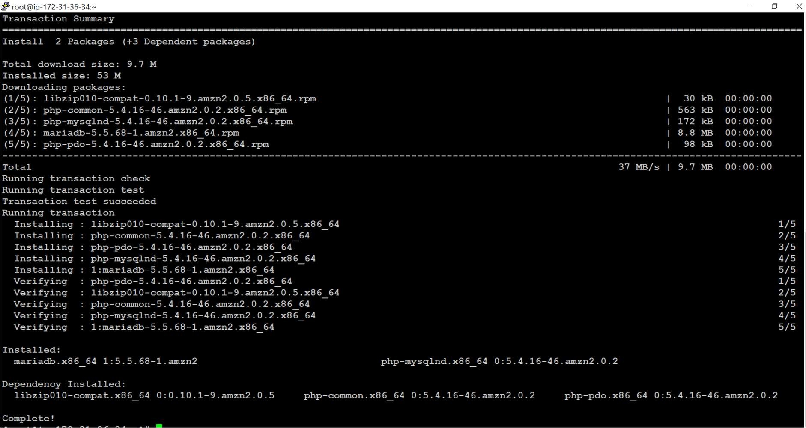

**Step 6 : Installing PHP software**

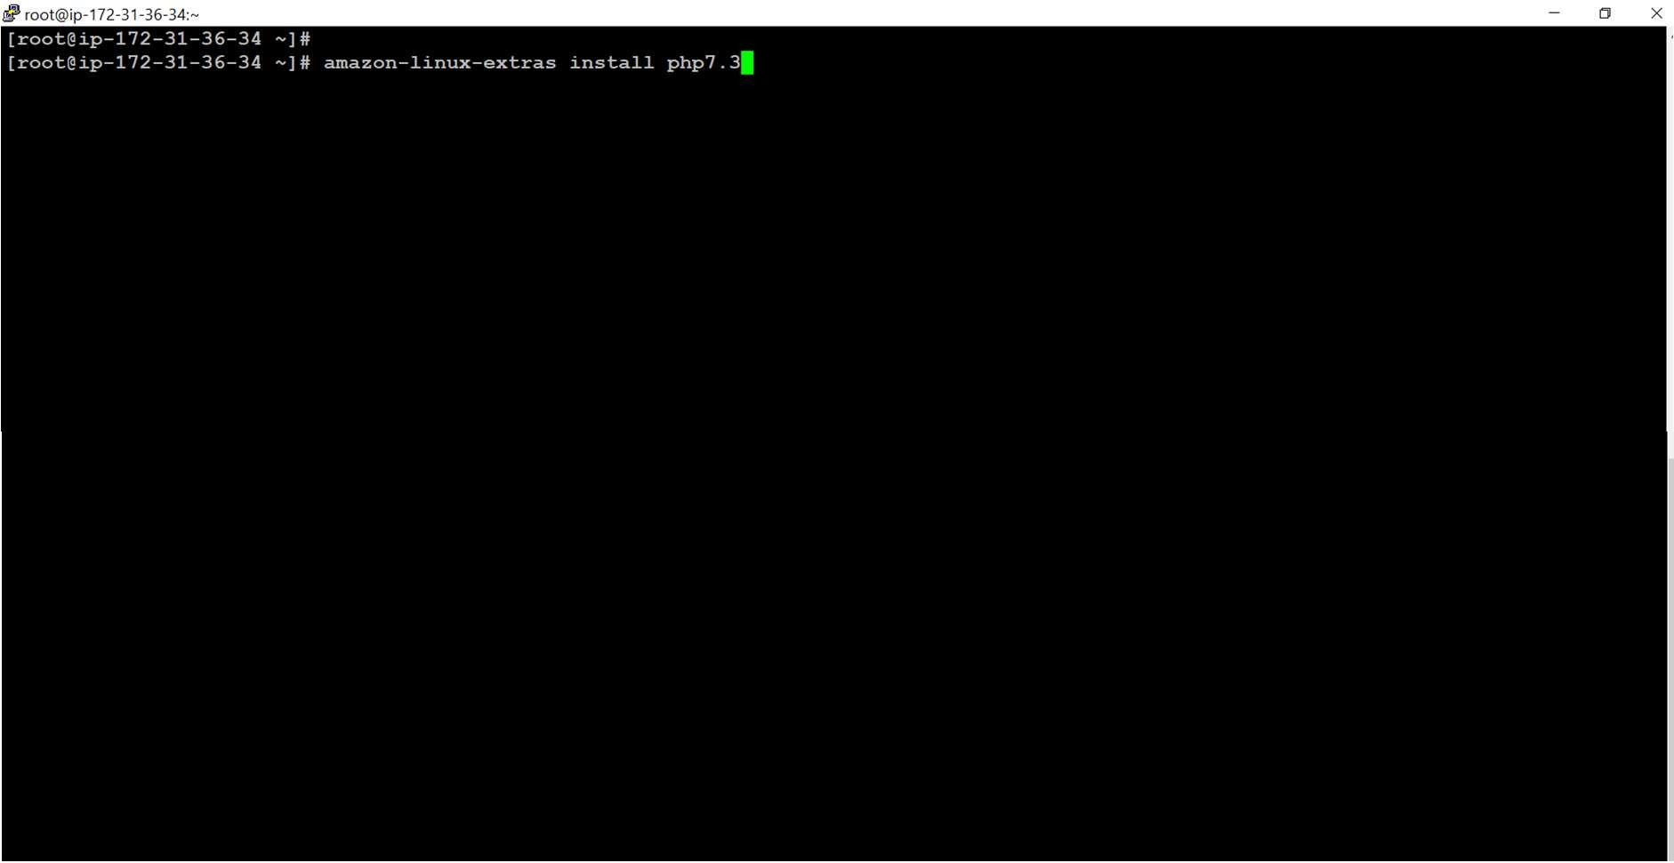

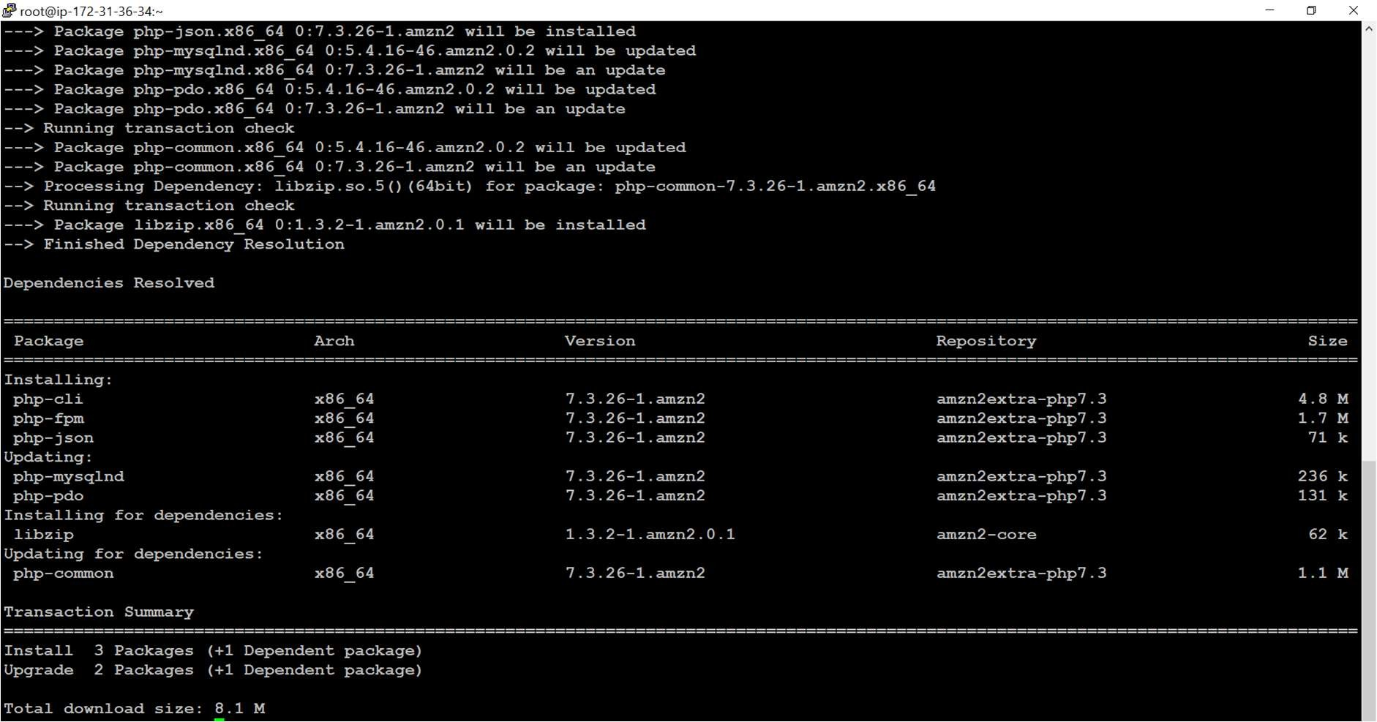

**Step 7 : Installing tar file of WordPress**

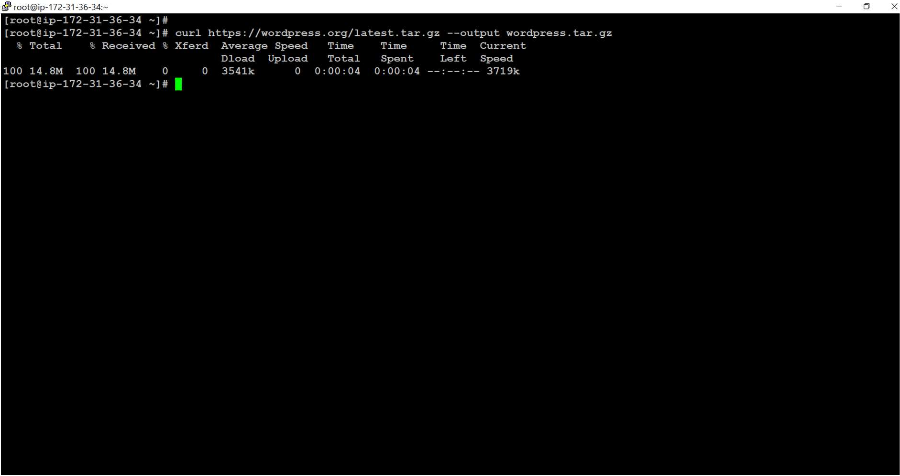

**Step 8 : Extracting tar file**

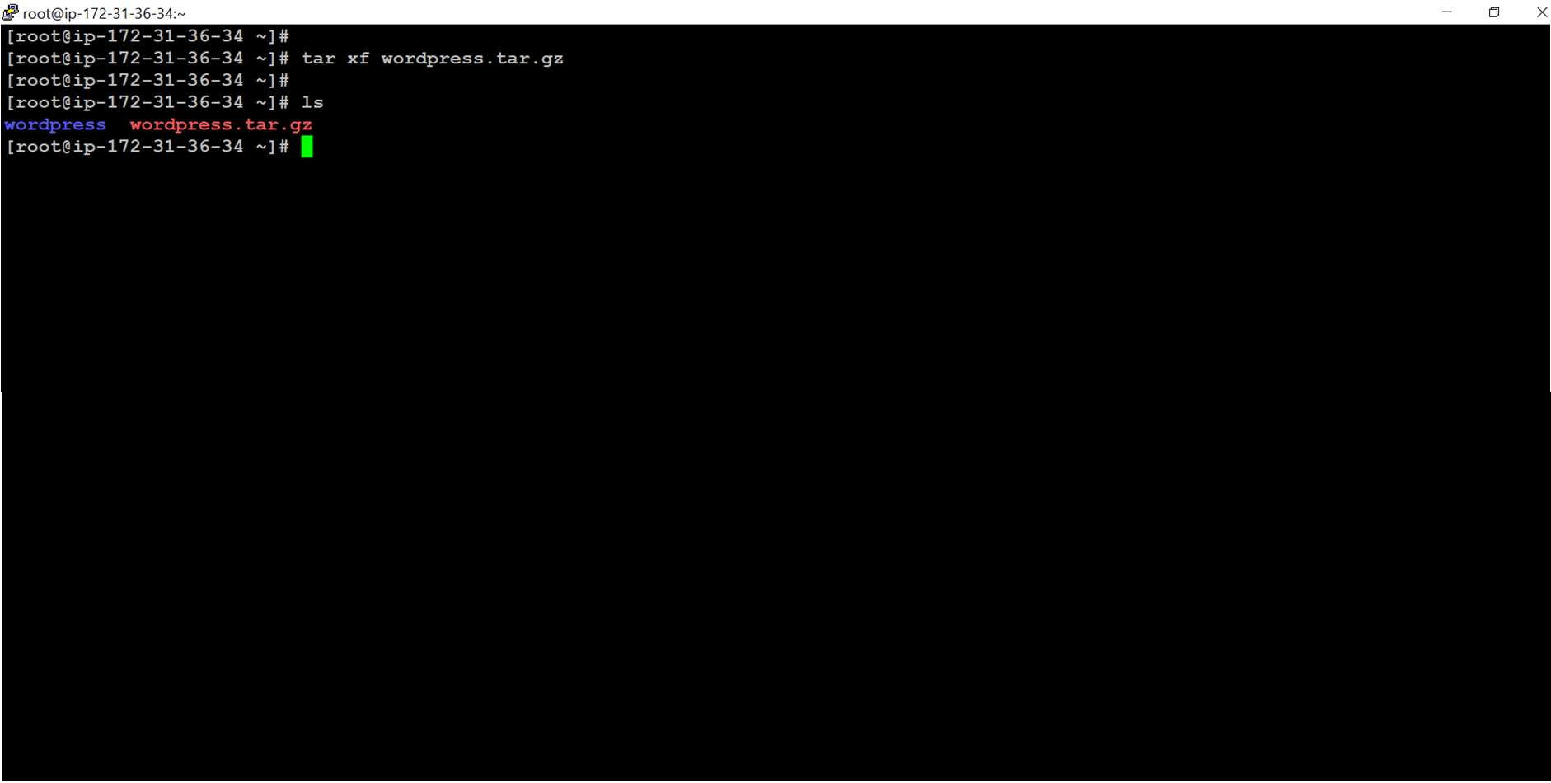

**Step 9 : Copying WordPress to html directory**

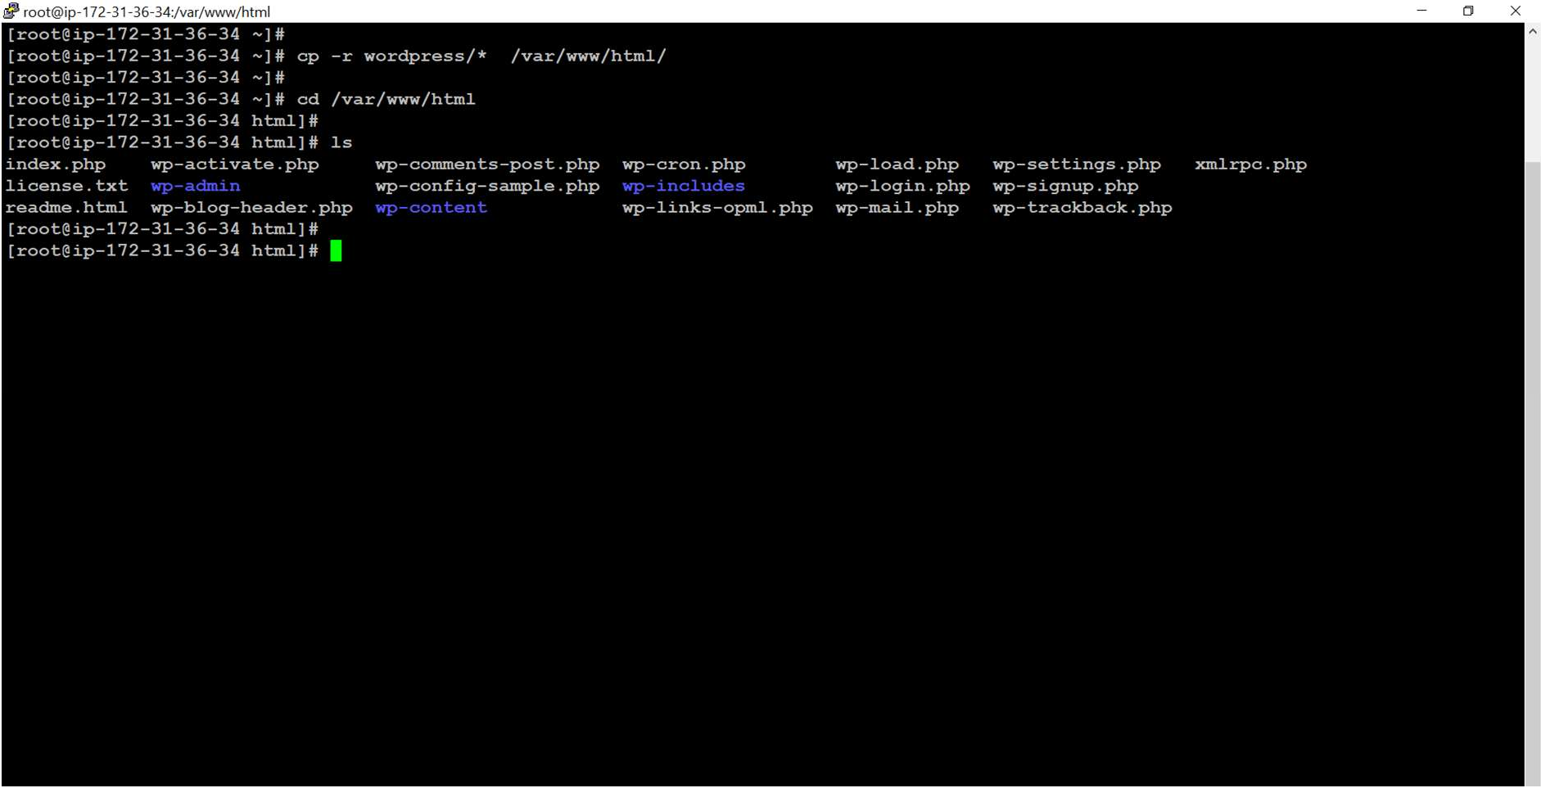

**Step 10 : Starting httpd webserver**

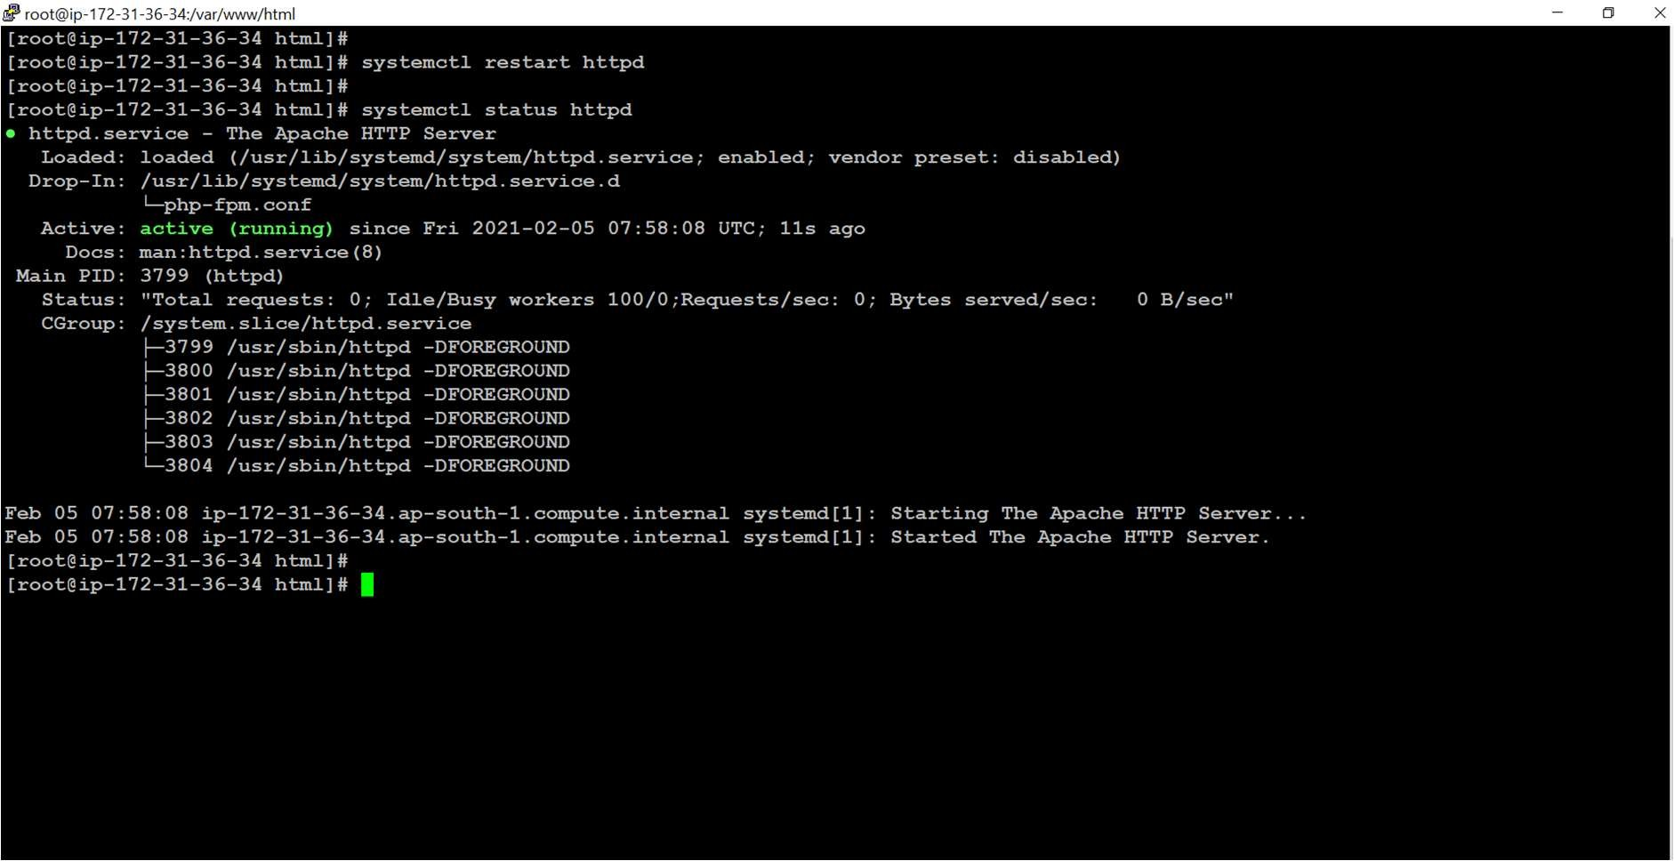

**Step 11: Creating MySQL Database**

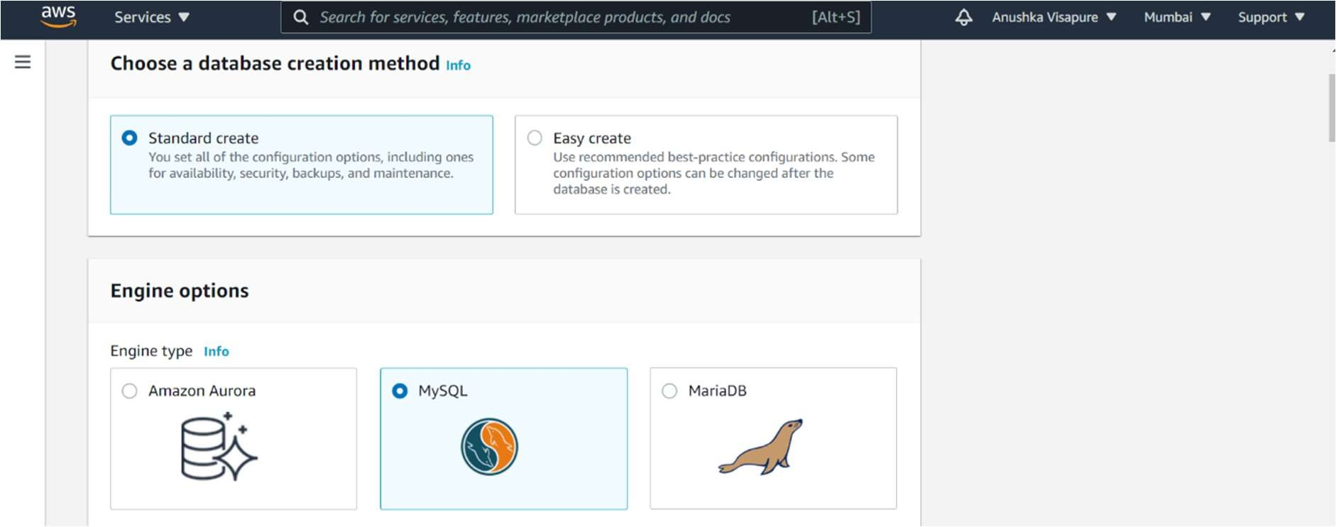

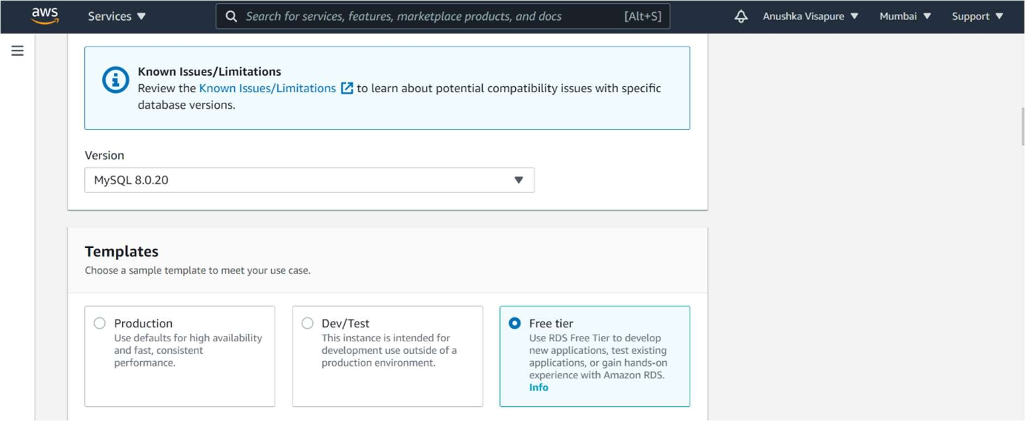

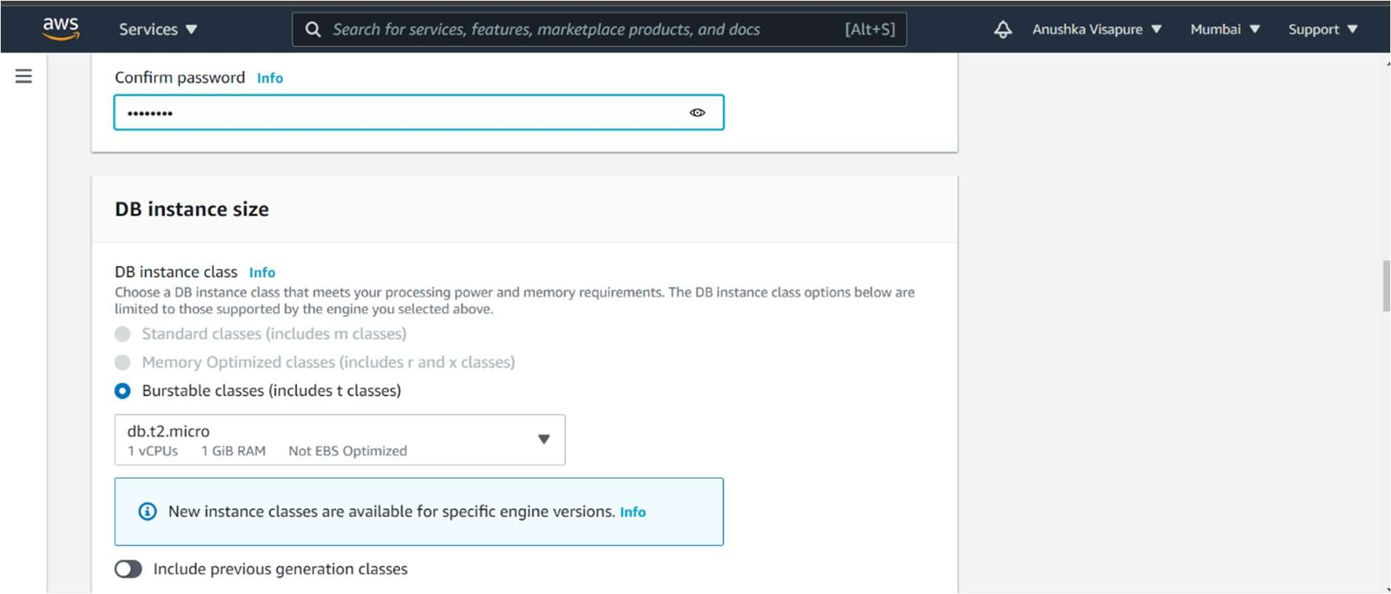

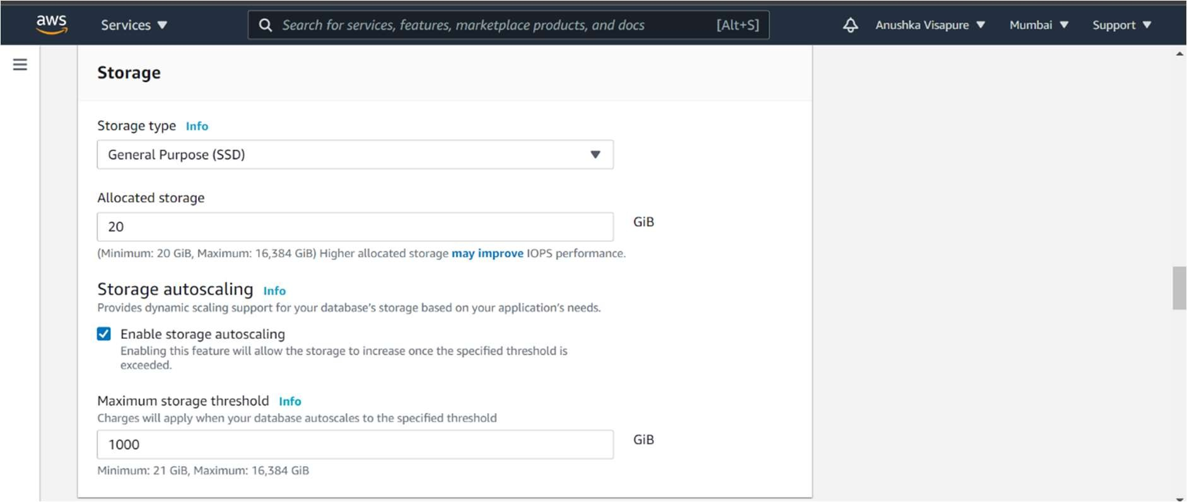

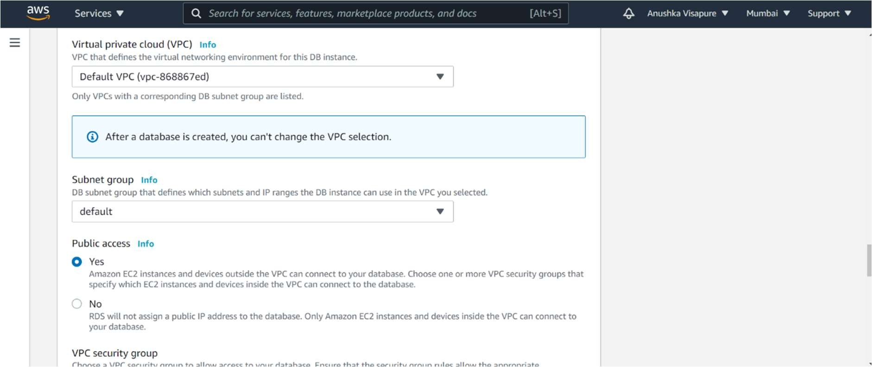

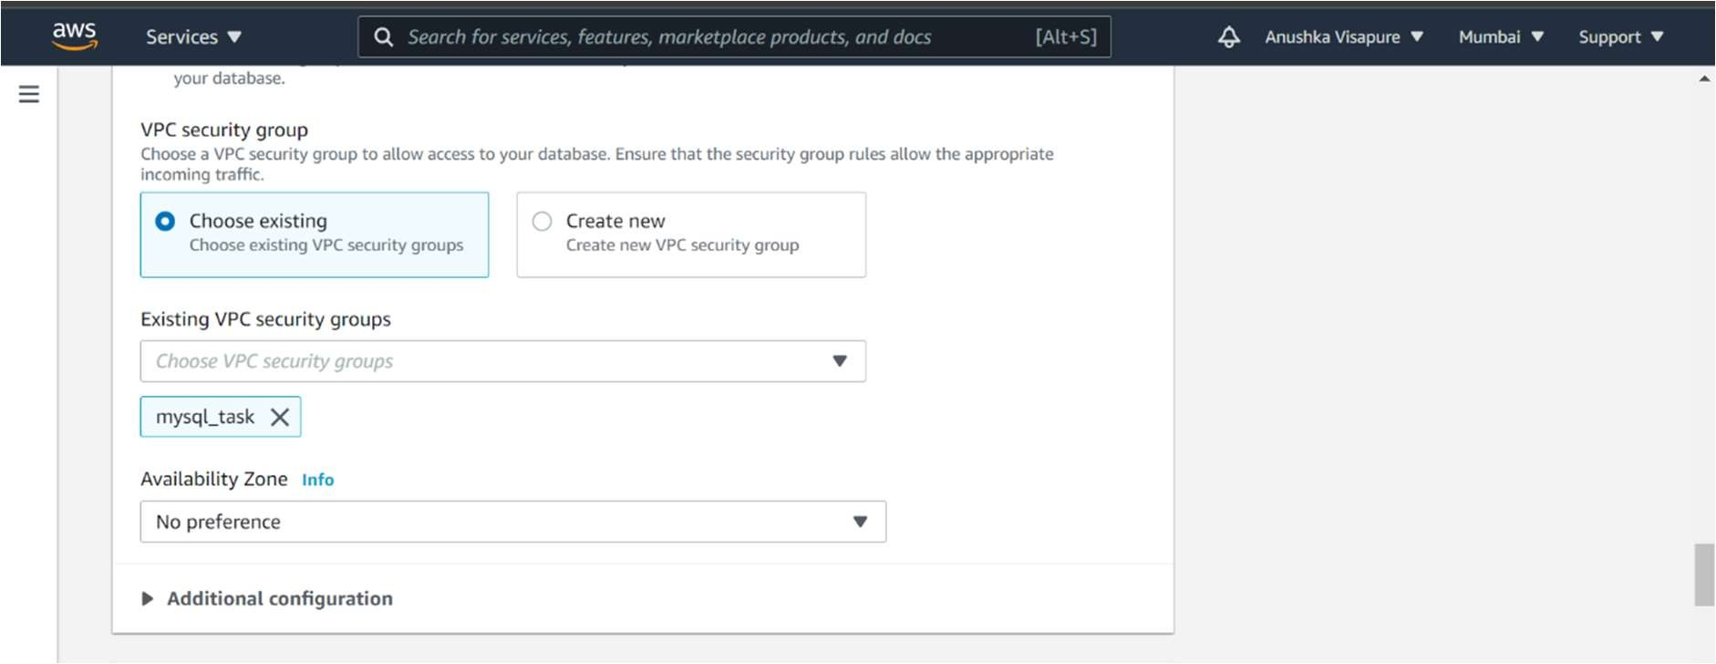

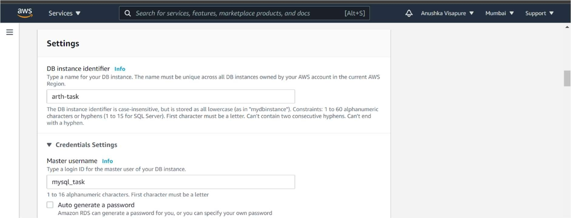

**Here we must give the database name , otherwise we can't access our WordPress application .**

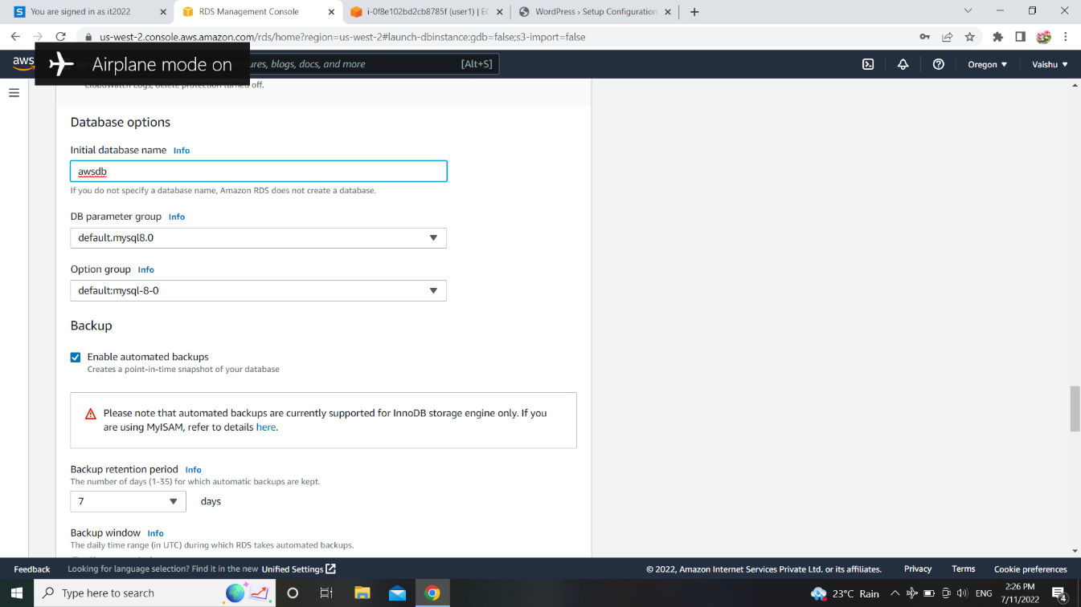

Now go to web-browser with the instance ip we can access our WordPress application.

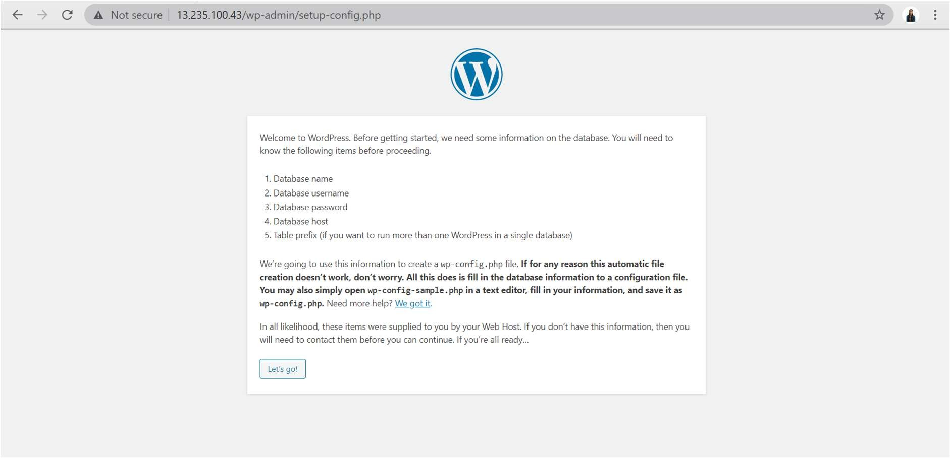

Here we need to provide basic information( database name , user name , password, Endpoint/Database host ) , while creating database , so that it will connect to our database . After submitting we will landed on login page of WordPress application

**Now you can face one error due to some configuration issue . Error like "unable to config wp-config.php file" . For that we need to copy the code from web-page ( from error page , where you have already give the wp-config.php file code ) and paste it into the html directory of instance with the name of wp-config.php**

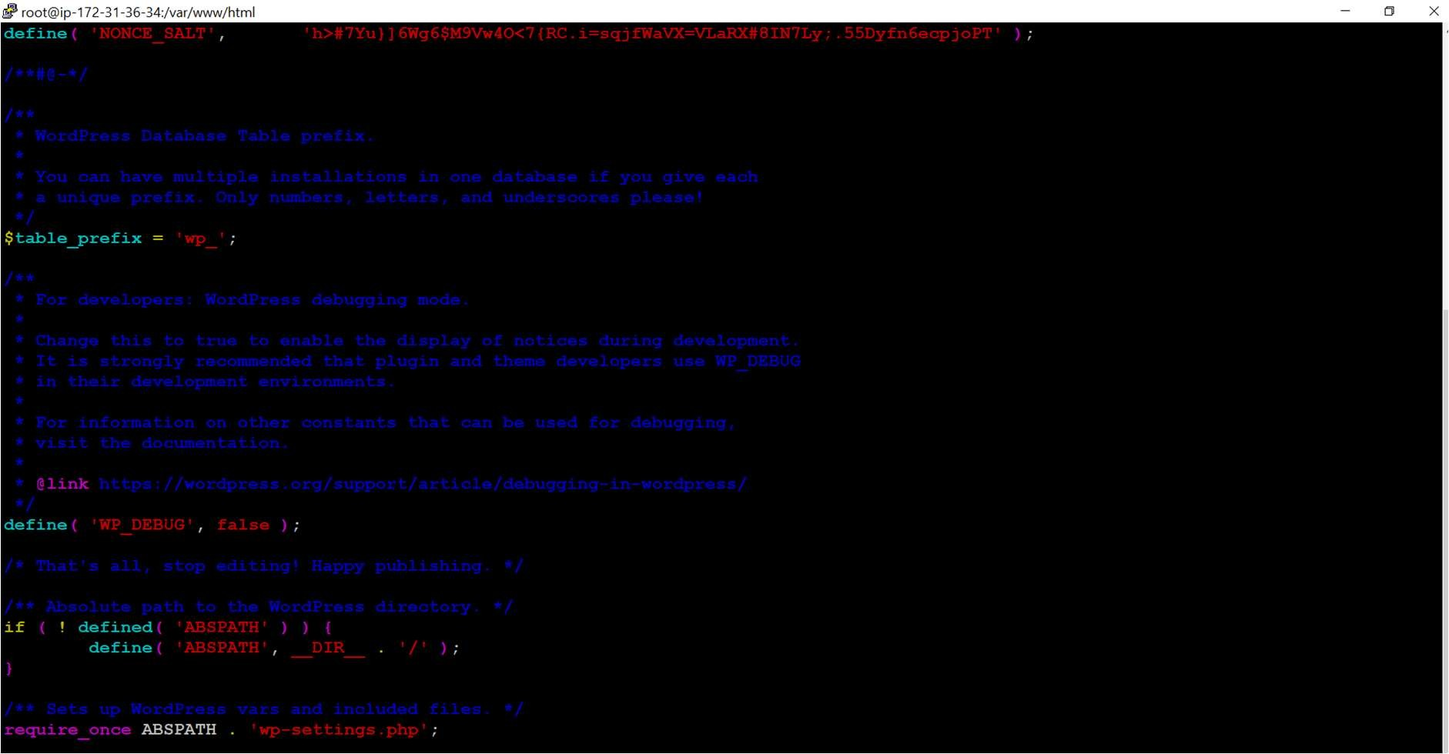

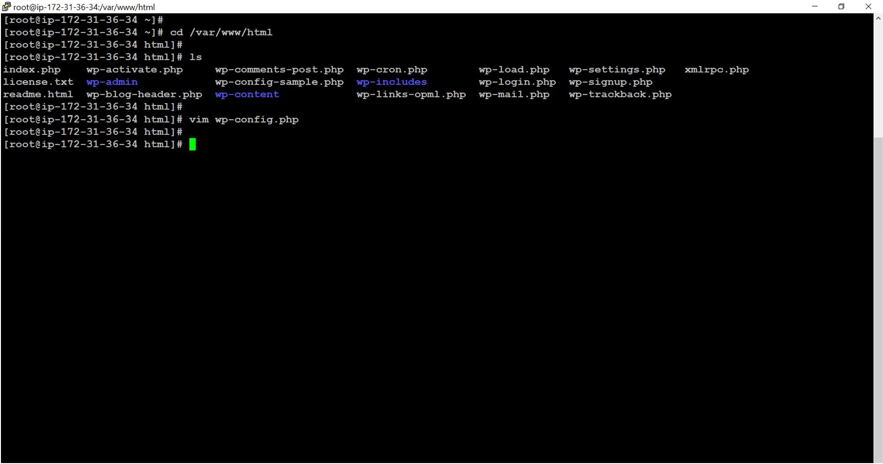

12]After creating the config file Now you have login in wordpress application.

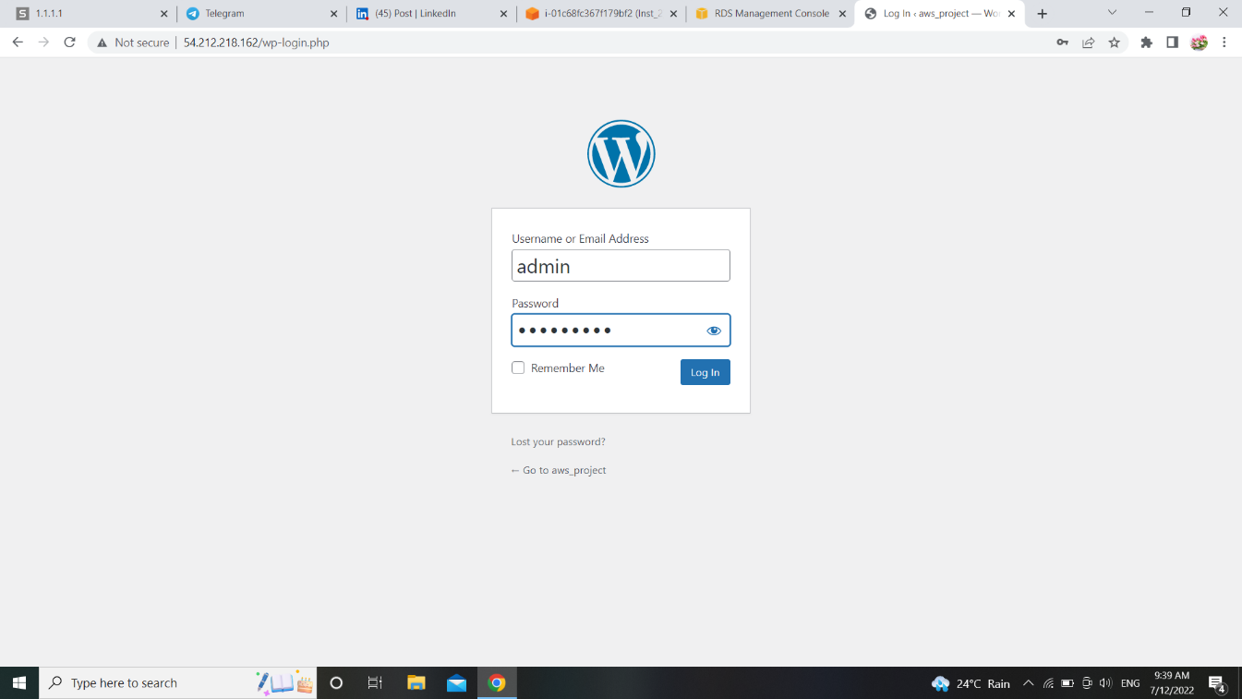

All set …. Lets see the output !!!

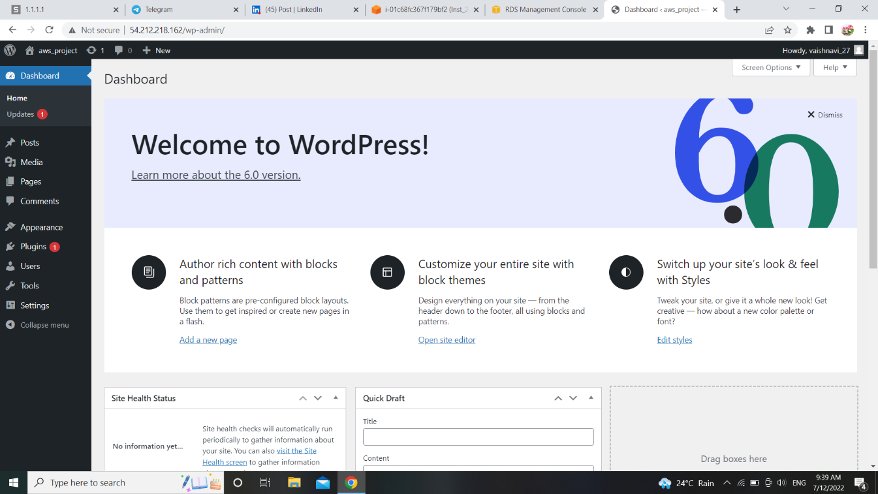

By following the same steps for configuration for second instance we gets this output.

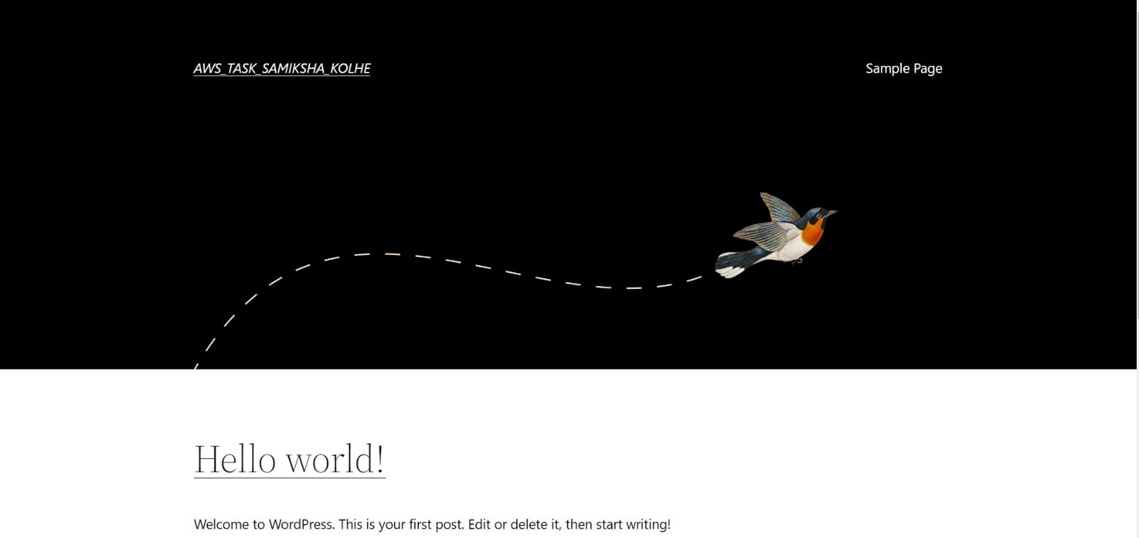

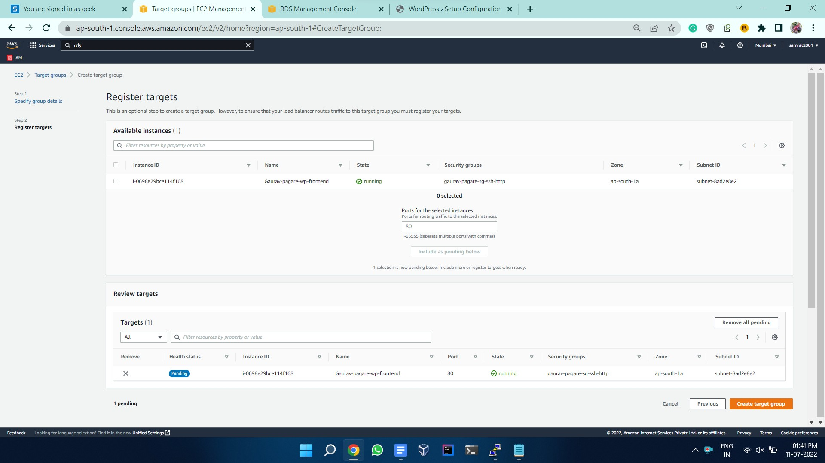13] **Launching Load Balancer :step 1:** At the most we need to create the target group and get those instances of wordpress in it.

Step 2: Now we need to create the ALB, here we want it to be internet facing and configure firewall for it which will allow hits over only port 80

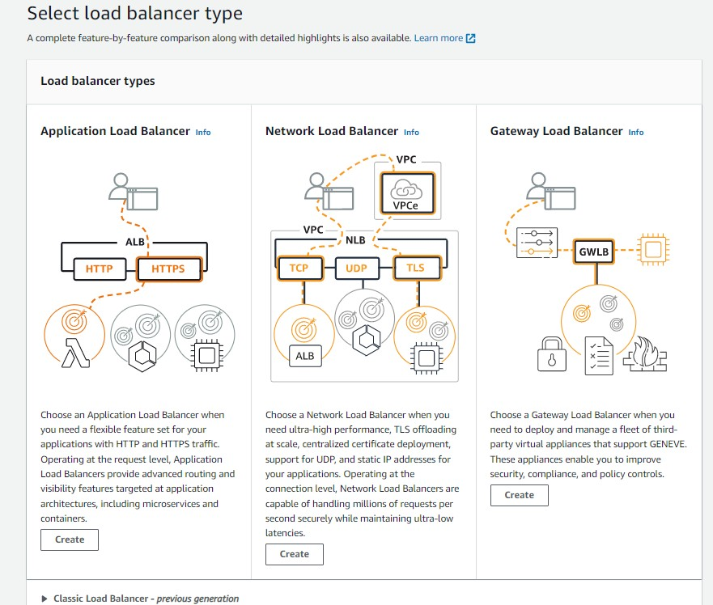

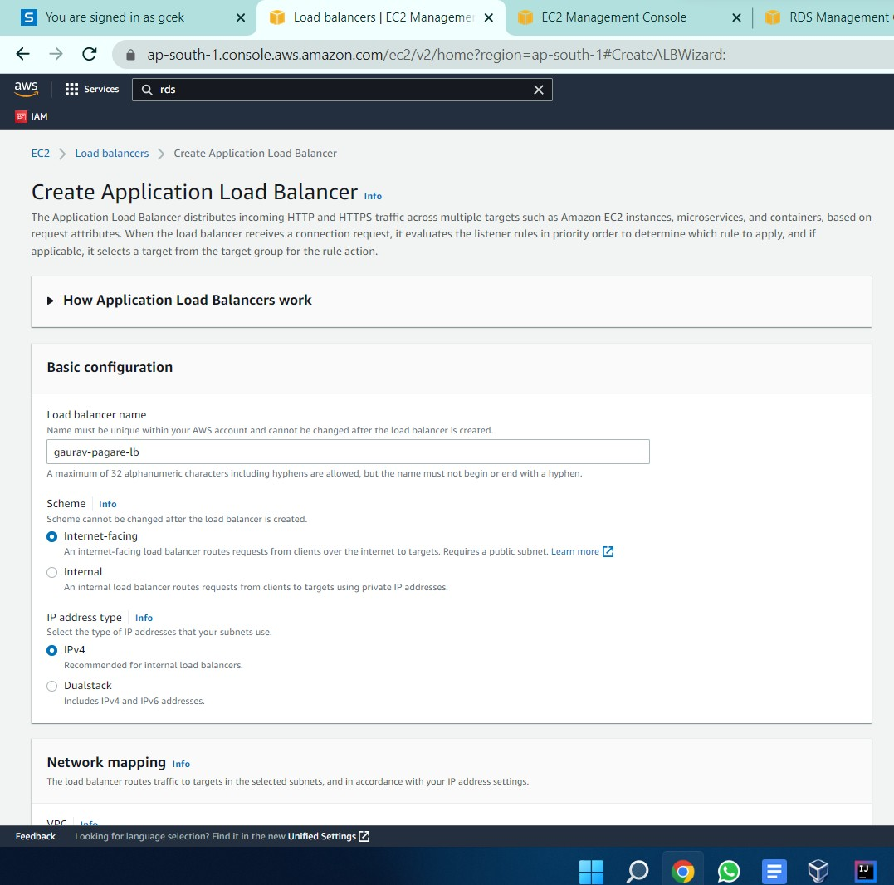

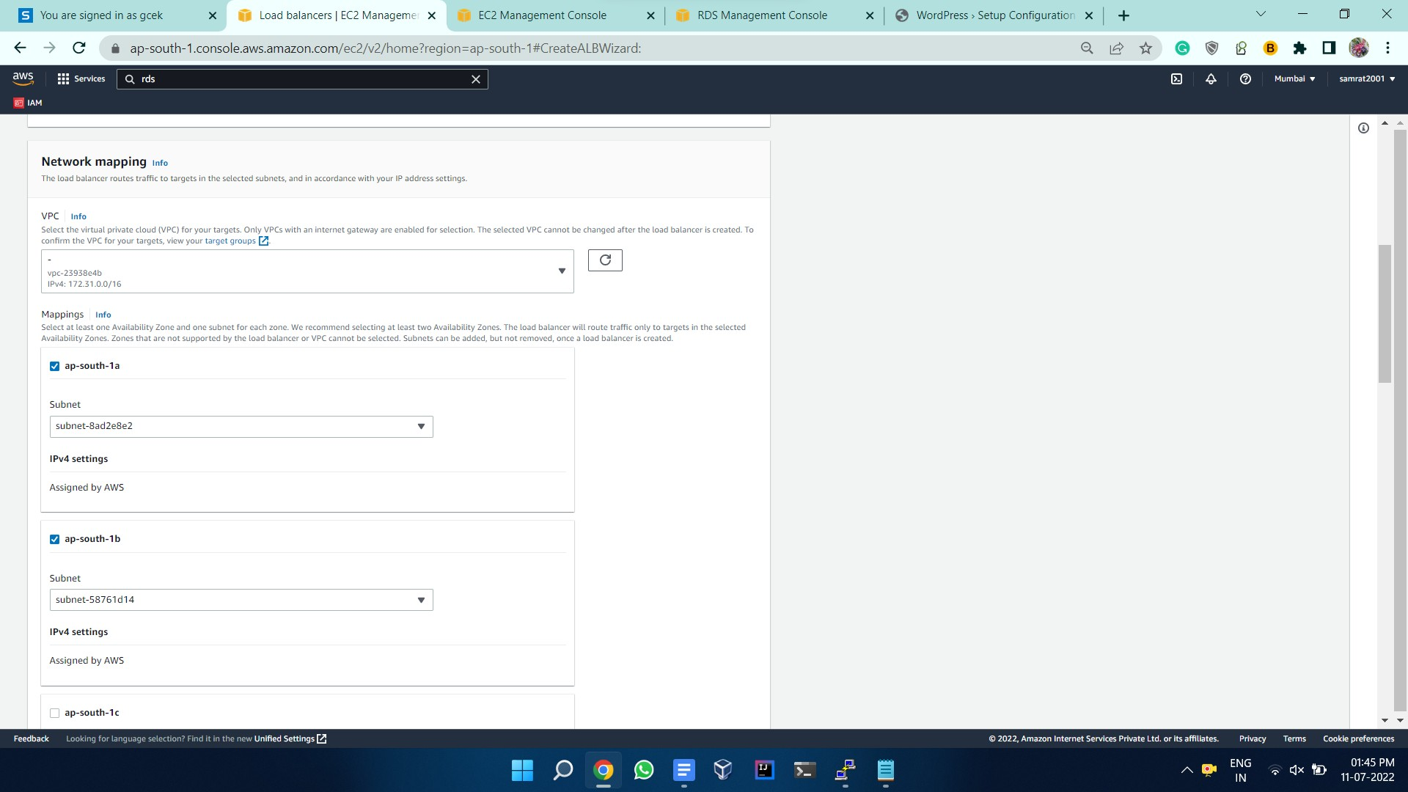Step 3: select the availability zone further target group and security group

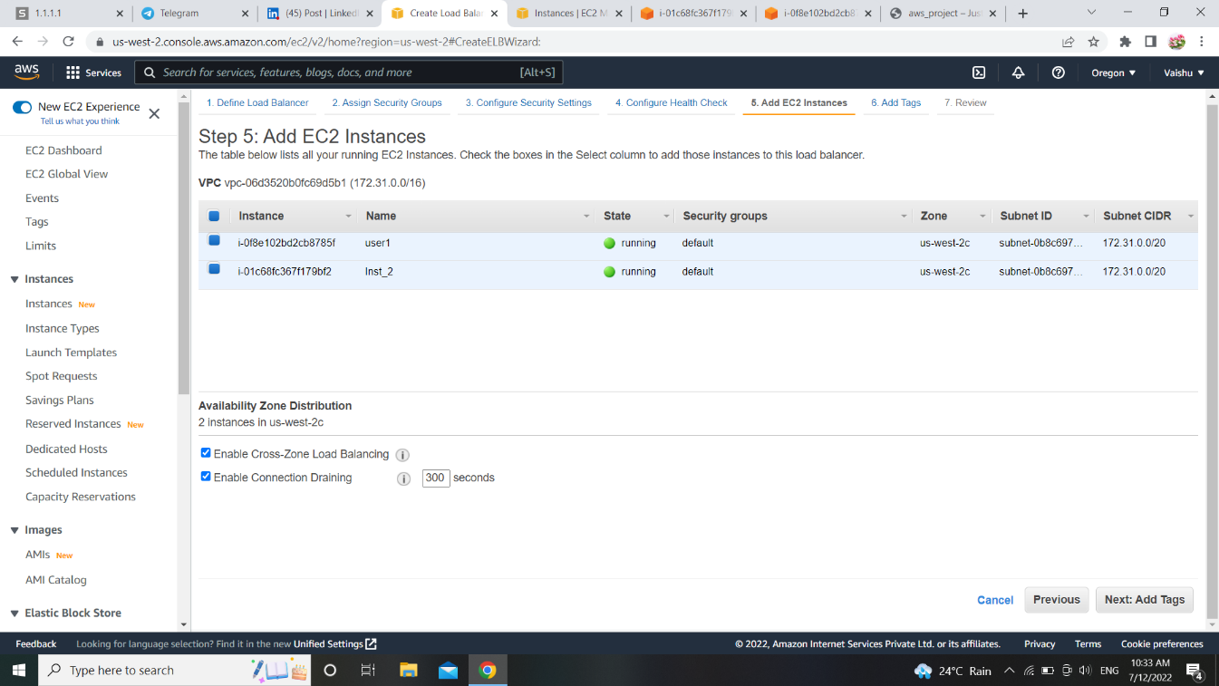

13] Load Balancer is created successfully.

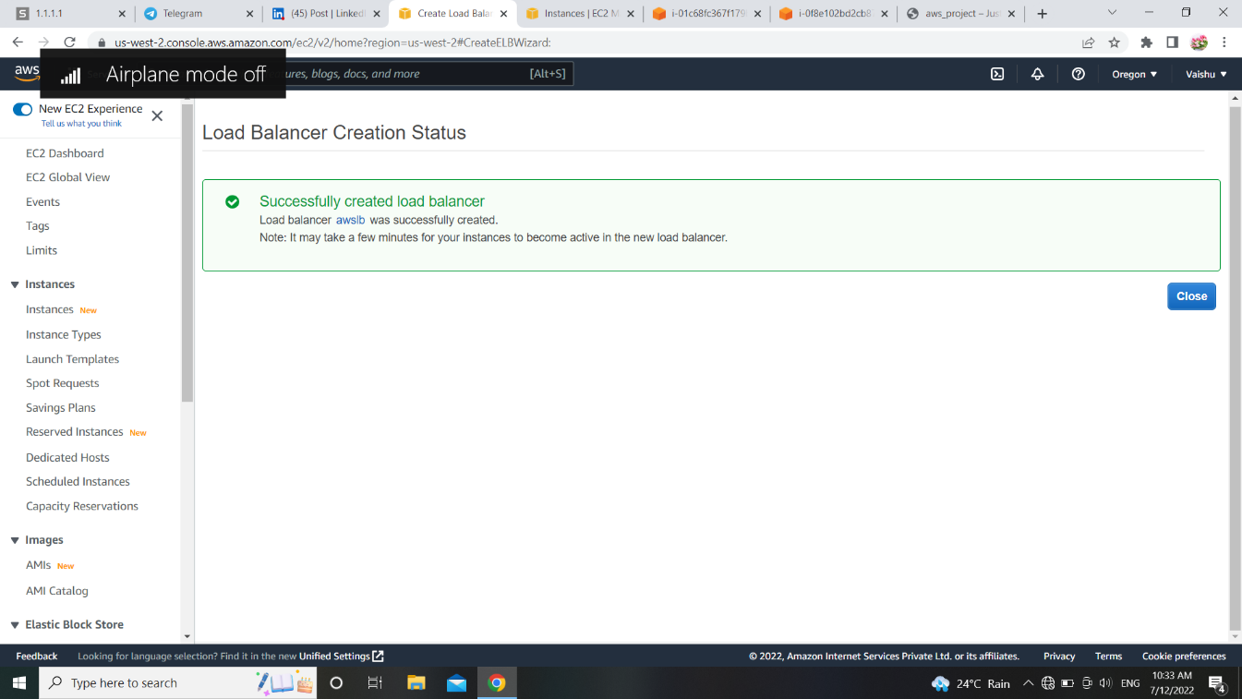

14] Finally we get our desired output. 